8th Grade
Numbers and Operations:
https://www.khanacademy.org/math/cc-eighth-grade-math

BEFOR YOU START
Coach planning: Talk to your partner coach and make a plan on who will do what. Talk about the math topics and make sure you have a clear understanding of what you will be doing with the students.

Review: Before going over this material ask the student to find a math problem from their class work that week. Ask the students to write the problem in the chat. Then practice the student problems as a group.

Note: If the students seem confident in the work and they are doing well with the practice problem you can progress to the next level of that topic. An example would be if the students are doing fine with addition with decimals in the 10s place move to the 100s place.

What if only one student is struggling with the work? A great way to approach this is to use a student that can do the problems. Ask the student who does understand the math to explain to you, step by step how to solve the equation. Example ‘Jane can you tell me how to solve 2 x (3 +5)=? What should I do first?’ this gives Jane a chance to show her skills but also does not draw attention to the fact that John is having a hard time.

Repeating Decimals:
Converting a fraction to a repeating decimal:
https://youtu.be/Y2-tz27nKoQ
Example:
What is 1.22222…. in a fraction form?
x=1.22222…..
10x=12.222….
-x -1.2222…
9x=11
/9 /9
x=11/9

Intro to Square roots:
https://youtu.be/mbc3_e5lWw0

We know that 3²=9
But what if you want to go the opposite way.
What is the square root of 9
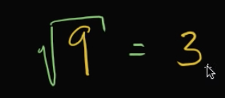
Remember, to find out the answer, what number when multiple itself would equal to 9?
Answer is 3

Example:
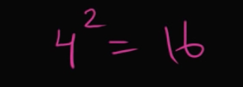

What is the 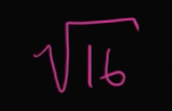?
what number when multiple itself would equal to 16?
The answer is 4. 4X4=16

